|  |
| --- |
| 新东方在线英语学习 |
| 新概念 1 册 |
| Lesson11-12 |



扫一扫。更多有趣的英语资讯。

# Lesson 1 单词讲解

1. whose: 谁的

what

whose pen\ whose shirt\ whose car

1. blue: 蓝色

1）忧郁的 You are blue today. 2）不健康的 It’s a blue book.

3）贵族的 blue blood

1. perhaps: 大概

Perhaps it is. 可能是这样吧~ Perhaps so.

Perhaps not. 可能不是这样~

1. white: 白色

the White House 白宫

white lie 善意的谎言

1. catch: 抓住、接着catch the thief catch the ball

# Lesson 11 课文讲解

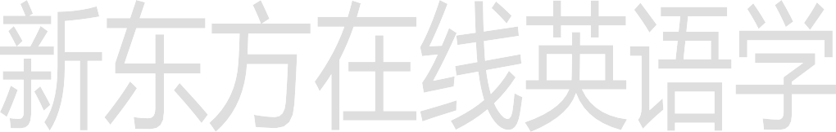

1. Whose shirt is that?

那是谁的衬衫？

whose shirt\ whose car\ whose friend… That is whose shirt?

特殊疑问词+ be+ 名词 n.

Whose is that shirt?

特殊疑问+名词+be+代词

Whose shirt is that?

这是谁的车？

Whose is this car?

Whose car is this? 那是谁的包？ Whose is this bag? Whose bag is this?

1. Is this your shirt, Dave?

大卫，这是你的衬衫吗？ 先生，打扰您一下。Excuse me， sir.

李老师，你好！

Hello, Mr. Lee.

1. Here you are. 给你

You are here.

1. 谁谁谁 “的” 我 的 ：my 你的：your

Lucy 的：？

Lucy’s

Lily 的：Lily’s

王先生的：Mr.Wang’s Lucy 的朋友：Lucy’s friend Lily 的书：Lily’s book

我妈妈的包：my mother’s bag 司机的手表：the driver’s watch 医生的车：the doctor’s car

# Lesson 11 语法讲解

1. father: 父亲

dad\ daddy 爸爸

1. mother: 母亲

mom\mum\ mummy 妈妈

1. blouse: 女衬衫 bu lai o z
2. sister: 姐姐
3. tie: 领带
4. brother: 兄弟
5. his: 他的
6. her: 她的

# Lesson 12 单词句型讲解

我的书：my book

你的房子：your house

他的领带：his tie

她的裙子：her dress

她妹妹是他的女朋友。Her sister is his girlfriend. 他太太是她的好朋友。His wife is her good friend. 他哥哥是她的老板。

His brother is her boss. Whose is this handbag?

Whose handbag is this? It’s Stella’s. Whose is this car?

Whose car is this? It’s Paul’s. Whose is this coat?

Whose coat is this? It’s Sophie’s.

翻译：

# Lesson 11&12 知识拓展

这是她男朋友的手表。

This is she boyfriend’s watch. This is she’s boyfriend’s watch. This is her boyfriend’s watch. 翻译：

那是他妻子的朋友。

That is he wife’s friend. That is he’s wife’s friend. That is his wife’s friend. 复习自然拼音

A /æ/ bag ,cat

B /b/ bat ,bad

C /k/ /s/ cat, city, cell phone, cyber name D /d/ dad, bad

E /e/ egg, deb

F / f / fat, daff

G /g/ get, give

H /h/ hat, him

I / ɪ / city, big



J /ʤ/

K /k/ L / l /

M /m/

N /n/

jet, job

kill, kiss

lot, let, girl, small man, climb, same not, no, man, town

O /D/ lot, orange, nod

P /p/ paper, pet, pot Q /kw/ qu quit, queen, quiet

R/ r / red, rabbit, road

S /s/ sad, bus, first

T /t/ Tom, top, it

U /ʌ/ cup, but, cut

V /v/ very, Venus, voice

W /w/ water, wait, what

X /ks/ fox, box, exit

Y /j/ yes, yet, yellow

/i/ happy, lovely, cloudy Z/z/ zip, zigzag , zero

Water wo de er

霍娜

微信：Tophuona